8Switching techniques
In large networks, there can be multiple paths from sender to receiver.
The switching technique will decide the best route for data transmission.
Switching technique is used to connect the systems for making one-to one communication.

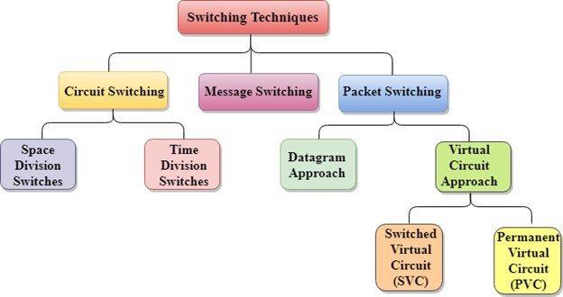

Message Switching
Message Switching is a switching technique in which a message is transferred as a complete unit and routed through intermediate nodes at which it is stored and forwarded.
In Message Switching technique, there is no establishment of a dedicated path between the sender and receiver.
The destination address is appended to the message. Message Switching provides a dynamic routing as the message is routed through the intermediate nodes based on the information available in the message.
Message switches are programmed in such a way so that they can provide the most efficient routes.
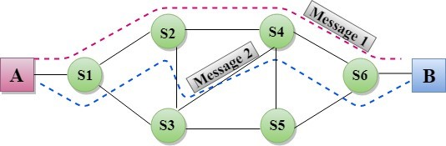
Each and every node stores the entire message and then forward
it to the next node. This type of network is known as
Message switching treats each message as an independent entity.
- Data channels are shared among the communicating devices that improve the efficiency of using available bandwidth.
Traffic congestion can be reduced because the message is temporarily stored in the nodes.
Message priority can be used to manage the network.
The size of the message which is sent over the network can be varied. Therefore, it supports the data of unlimited size.
The message switches must be equipped with sufficient storage to enable them to store the messages until the message is forwarded.
The Long delay can occur due to the storing and forwarding facility provided by the message switching technique.

Difference Between Circuit Switching And Packet Switching:
The following table compares circuit switching and packet switching techniques-
Circuit Switching | Packet Switching
 | Virtual Circuit Switching | Datagram Switching
Connection oriented service | Connection oriented service | Connection less service
Ensures in order delivery | Ensures in order delivery | Packets may be delivered out of order
No reordering is required | No reordering is required | Reordering is required
A dedicated path exists for data transfer | A dedicated path exists for data transfer | No dedicated path exists for data transfer
All the packets take the same path | All the packets take the same path | All the packets may not take the same path
Resources are allocated before data transfer | Resources are allocated on demand using 1st packet | No resources are allocated
Stream oriented | Packet oriented | Packet oriented
Fixed bandwidth | Dynamic Bandwidth | Dynamic bandwidth
Reliable | Reliable | Unreliable
No header overheads | Only label overheads | Higher overheads
Implemented at physical layer | Implemented at data link layer | Implemented at network layer
Inefficient in terms of resource utilization | Provides better efficiency than circuit switched systems | Provides better efficiency than message switched systems
Example- Telephone systems | Examples- X.25, Frame relay | Example- Internet

SOFTSWITCH ARCHITECTURE
The latest trend in the development of circuit-switching technology is generally referred to as the soft switch. In essence, a soft switch is a general-purpose computer running specialized software that turns it into a smart phone switch. Soft switches cost significantly less than traditional circuit switches and can provide more functionality.
A soft switch can convert a stream of digitized voice bits into packets. This opens up a number of options for trans-mission, including the increasingly popular voice over IP (Internet Protocol) approach. In any telephone network switch, the most complex element is the software that controls call processing. This software performs call routing and implements all-processing logic for hundreds of custom calling features.
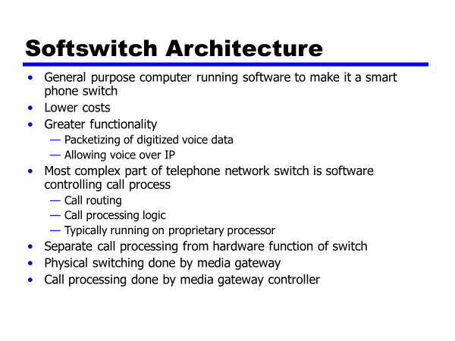
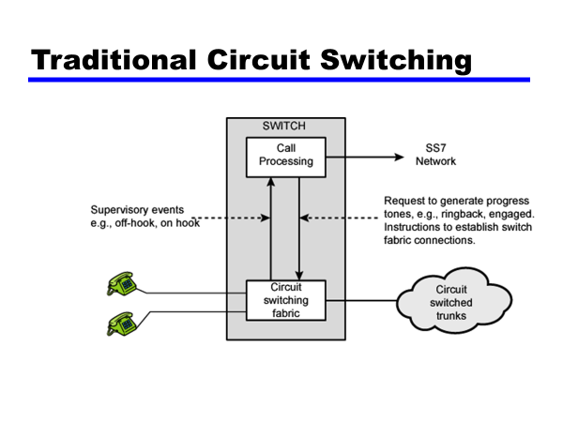
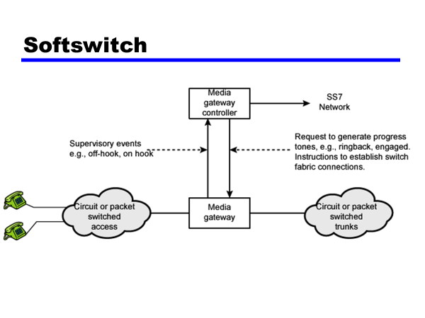

X.25:
X.25 is a protocol suite defined by ITU-T for packet switched communications over WAN (Wide Area Network). It was originally designed for use in the 1970s and became very popular in 1980s. Presently, it is used for networks for ATMs and credit card verification. It allows multiple logical channels to use the same physical line. It also permits data exchange between terminals with different communication speeds.
X.25 has three protocol layers
- Physical Layer: It lays out the physical, electrical and functional characteristics that interface between the computer terminal and the link to the packet switched node. X.21 physical implementer is commonly used for the linking.
- Data Link Layer: It comprises the link access procedures for exchanging data over the link. Here, control information for transmission over the link is attached to the packets from the packet layer to form the LAPB frame (Link Access Procedure Balanced). This service ensures a bit-oriented, error-free, and ordered delivery of frames.
- Packet Layer: This layer defines the format of data packets and the procedures for control and transmission of the data packets. It provides external virtual circuit service. Virtual circuits may be of two types: virtual call and permanent virtual circuit. The virtual call is established dynamically when needed through call set up procedure, and the circuit is relinquished through call clearing procedure. Permanent virtual circuit, on the other hand, is fixed and network assigned.

Equipment used
- X.21 implementer
- DTE − Data Terminal Equipment
- DCTE − Data Circuit Terminating Equipment

Frame Relay
Frame Relay is a packet switched communication service from LANs (Local Area Network) to backbone networks and WANs. It operates at two layers: physical layer and data link layer. It supports all standard physical layer protocols. It is mostly implemented at the data link layer.
Frame Relay uses virtual circuits to connect a single router to multiple remote sites. In most cases, permanent virtual circuits are used, i.e. a fixed network-assigned circuit is used through which the user sees a continuous uninterrupted line. However, switched virtual circuits may also be used.
Frame relay is a fast packet technology based on X.25. Data is transmitted by encapsulating them in multiple sized frames. The protocol does not attempt to correct errors and so it is faster. Error correction is handled by the endpoints, which are responsible for retransmission of dropped frames
Frame Relay Devices are:
DTE − Data Terminal Equipment
DCTE: − Data Circuit Terminating Equipment

ATM protocol architecture
The asynchronous transfer mode (ATM) protocol architecture is designed to support the transfer of data with a range of guarantees for quality of service. The user data is divided into small, fixed-length packets, called cells, and transported over virtual connections. ATM operates over high data rate physical circuits, and the simple structure of ATM cells allows switching to be performed in hardware, which improves the speed and efficiency of ATM switches.
Figure below shows the reference model for ATM. The first thing to notice is that, as well as layers, the model has planes. The functions for transferring user data are located in the user plane; the functions associated with the control of connections are located in the control plane; and the co-ordination functions associated with the layers and planes are located in the management planes.
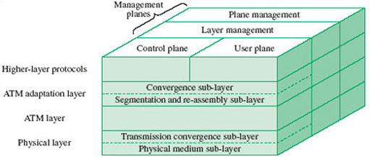
Figure: ATM reference model
The three-dimensional representation of the ATM protocol architecture is intended to portray the relationship between the different types of protocol. The horizontal layers indicate the encapsulation of protocols through levels of abstraction as one layer is built on top of another, whereas the vertical planes indicate the functions that require co-ordination of the actions taken by different layers. An advantage of dividing the functions into control and user planes is that it introduces a degree of independence in the definition of the functions: the protocols for transferring user data (user plane) are separated from the protocols for controlling connections (control plane).

What is Cell in ATM?
Cell in ATM is a 53-byte packet of data, the standard packet size used by Asynchronous Transfer Mode (ATM) communication technologies. Cells are to ATM technologies what frames are to Ethernet networking. In other words, they form the smallest element of data for transmission over the network.
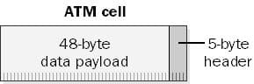ATM cell

How ATM Cells work
ATM cells are standardized at a fixed-length size of 53 bytes to enable faster switching than is possible on networks using variable-packet sizes (such as Ethernet). It is much easier to design a device to quickly switch a fixed-length packet than to design a device to switch a variable-length packet. (Switching a fixed-length packet is easier because the device knows in advance the exact length of the packet and can anticipate the exact moment at which the last portion of the packet will be received. With variable-length packets, the device must examine each packet for length information.) Using fixed-length cells also makes it possible to control and allocate ATM bandwidth more effectively, making support for different quality of service (QoS) levels for ATM possible.
The functions of information stored in the 5-byte header of an ATM cell include the following:
- Providing information about the physical layer transmission method being used
- Providing flow control to enable a steady flow of cell traffic and to reduce cell jitter
- Specifying virtual path or channel identification numbers so that multiplexed cells belonging to the same ATM connection can be distinguished from cells belonging to other ATM connections, and so that cells can be switched to their intended destination
- Specifying the nature of the payload contained in the cell—that is, whether it contains actual user data or ATM cell-management information
- Specifying the priority of the cell to determine whether the cell can be dropped in congested traffic conditions
- Providing error checking by means of an 8-bit field containing cyclical redundancy check (CRC) information for the header itself

ATM Transmission
Asynchronous Transfer Mode (ATM) networking is an outgrowth of efforts during the 1970s and 1980s to develop a broadband Integrated Service Digital Network (ISDN) capability. ATM provides a transport mechanism that allows digital data to be efficiently transmitted over high-speed links. Currently, most of the high-speed backbone networks throughout the world use ATM technology. It is also used to some extent as a local area networking technology, although the availability of low-cost 100 megabyte and gigabyte Ethernet equipment reduces its appeal for this application.
ATM technology was developed to support a blending of circuit-switching and packet-switching technologies. It is intended to support traffic that requires a fairly constant rate of data delivery, such as voice and video, as well as variable data rate traffic, such as most computer data. ATM is a connection-oriented technology. This means that a fixed path through the network must be established before data can be transmitted. In this respect, ATM is similar to earlier telephone technologies in which physical wires between switching centers were allocated for the duration of each telephone call. Establishing an ATM connection causes a virtual channel connection (VCC) or virtual circuit (VC) to be created through the ATM network between the end users of the connection.
Virtual channels can be bundled into virtual paths in much the same way that physical wires were bundled into trunk lines. Virtual channels can be either permanent virtual channels (PVCs), established manually and persisting for long periods of time, or switched virtual channels (SVCs), set up dynamically as needed and torn down when the need no longer exists.
Data traveling over a VC are divided into fixed-length packets called cells. Each cell contains forty-eight bytes of user data and five bytes of header. Three of the header bytes are used to identify the virtual path (eight bits ) and virtual channel (sixteen bits). One byte is used for header error checking, and the remaining eight bits are used for flow control (four bits), payload type (three bits), and priority (one bit). The small payload size benefits services such as voice and video, where timely and regular delivery are required.
ATM supports five different classes of service:
- Constant bit rate (CBR) allows the desired bit rate to be set when the virtual circuit is established; it is used for services such as uncompressed voice and video;
- Variable bit rate–non-real time (VBR–NRT) allows statistical techniques to be used to optimize network throughput when the rate at which data is available varies;
- Variable bit rate–real time (VBR-RT) is intended for applications such as compressed speech and video, where data delivery must occur at regular intervals;
- Available bit rate (ABR) is used for non-time-critical operations such as bulk file transfers that can adjust their rate of input to use available network capacity; minimum acceptable rates can be specified to ensure some service at all times.
- Unspecified bit rate (UBR) is the residual class with no guaranteed properties; it is used primarily for TCP/IP data traffic.
When an ATM connection is established, a number of parameters may be specified to ensure desired service properties such as acceptable cell loss percentage, maximum delivery time, variation in delivery time, and the variability of variable rate sources, which specify peak and average data rates and the maximum duration of a burst of peak-rate traffic. Not all parameters apply to all classes of service. Variability parameters make no sense for constant-rate connections, for example. The ability to specify both the type of service needed and parameters controlling the quality of service make ATM well suited to deliver data for multimedia applications.

The ATM Forum is a non-profit international organization dedicated to speeding the development and mass-market deployment of ATM broadband communications technologies. The forum is focused on development of interoperability specifications, promotion of industry-wide cooperation, and educational awareness of the technology's capabilities. Among its other activities, the forum defines standards for connecting other networking technologies to ATM systems. This is necessary because few if any applications use the forty-eight byte data cell payloads of ATM as their native format. A number of ATM adaptation layer (AAL) standards exist that specify the methods to be used.
AAL-1 provides for the conversion of voice and video circuits to CBR ATM virtual channels. The use of PVCs emulates fixed physical circuits and is generally wasteful of bandwidth, as few point-to-point circuits carry fixed traffic levels for long periods of time. The use of SVCs for this traffic represents an improvement, but is still far from optimum, because voice traffic is characterized by lengthy periods of silence, such as when one party is listening to the other. AAL-2 provides a VBR–RT trunking mechanism that uses statistical multiplexing techniques to eliminate the cells that would contain silence.
Compressed video in the MPEG-2 format is accommodated by either AAL-1 or CBR AAL-5. The use of AAL-1 provides for forward error correction at the expense of increased bandwidth and delivery delay. It also allows compensation for Cell Delay Variation (CDV) and the replacement of lost cells. AAL-5 does not compensate for CDV or for bit errors, and lost cells cannot be replaced. For these reasons, AAL-1 is recommended when high video quality is needed.
Internet data traffic also travels over ATM circuits. These data typically take the form of Internet Protocol (IP) datagrams that range in length from a few bytes to thousands of bytes. At the lowest levels of the protocol stack, each datagram is treated independently, and delivery is on a best-effort basis where some loss is deemed acceptable. Higher-level protocols add additional information to the datagram payloads to ensure that they are delivered reliably and in the proper order, retransmitting lost datagrams as necessary. These functions are provided at the end points and are not part of the network routing structure. It would be possible to set up a VCC for a single datagram and tear it down once the packet had been delivered, but the overheads would be excessive. Instead, ATM connections are established between Internet routers. These connections are treated as equivalent to direct physical links between the routers, with the virtual circuit carrying traffic for multiple users. IP over ATM typically uses UBR AAL-5 connections. A potential problem occurs in mapping IP datagrams into ATM cell payloads, because loss of a single cell necessitates retransmission of the entire datagram.

